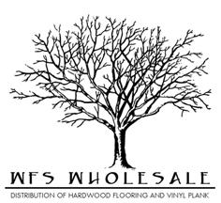
Summerland Hickory Specifications
Species | Hickory
Size | 6 ½”x3/8”xRL
Top Layer | 1.2 mm
Sqft per ctn | 31.97
Lengths | 18”-72”
Construction | Engineered- Tongue and Grove
Plies | 6
Style | Hand Scraped
Finish | 7 layer UV Coating
Edges | T&G eased edge
Installation | Staple, Nail, Glue, or Float
Warranty | 50 year finish & lifetime structure

