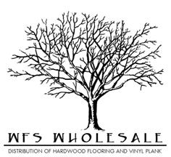
Southampton Specifications
Species | Hickory
Size | 6 ½”x ½”
Top Layer | 2 mm
Sqft per ctn | 25.57
Lengths | RL up to 6’
Construction | Engineered- Tongue and Grove
Plies | 6
Style | Hand Scraped
Finish | 7 layer UV Coating
Edges | T&G eased edge
Installation | Staple, Nail, Glue, or Float
Warranty | 50 year finish & lifetime structure

