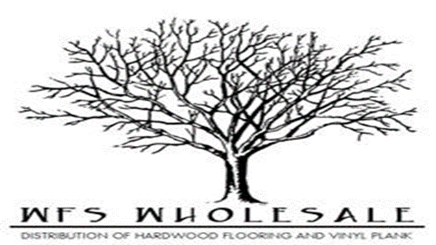

Old River Specifications
Species | Oak
Sizes | 3 ¼” x ¾” x RL
Sqft per ctn | 27 sqft/ctn
Finish | Aluminum Oxide
Style | Smooth Face
Lengths | 9”-84” (average 32”)
Installation | Nail/ Staple
Application | Above Grade/ On Grade
Warranty | Lifetime Finish and Structure

