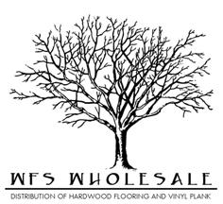
Hermosa Hickory Specifications
Species | Hickory
Size | 5”x3/8”xRL
Top Layer | 1.5 mm
Sqft per ctn | 29.12
Lengths | 18”-48”
Construction | Engineered- Tongue and Groove
Plies | 5
Style | Hand Scraped
Finish | 7 layer UV Coating
Edges | T&G eased edge
Installation | Staple, Nail, Glue, or Float
Warranty | 50 year finish & lifetime structure

