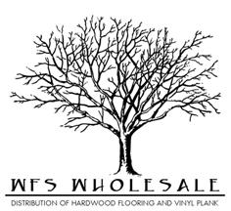
Grand Haven Specifications
Species | Hickory
Size | 3/8" x 3, 5, 7
Top Layer | 1.5 mm
Sqft per ctn | 29.53
Lengths | RL
Construction | Engineered- Tongue and Grove
Plies
Style | Hand Scraped
Finish | 7 layer UV Coating
Edges | T&G eased edge
Installation | Staple, Nail, Glue, or Float
Warranty | 50 year finish & lifetime structure

